The definition of AI can be grouped into four categories briefly explain the four categories

2 / 2

Yes, the definition of AI can be broadly categorized into four different categories:

1. Reactive Machines: Reactive machines are the simplest form of AI, which are designed to react to specific situations based on pre-programmed rules. They do not have any memory, so they can only react to the current situation without any context of the past or future. Examples of reactive machines include Deep Blue (chess-playing computer) and AlphaGo (Go-playing computer).
2. Limited Memory: Limited memory AI systems have the ability to learn from past experiences and improve their performance based on that learning. These systems can use historical data to make better decisions in the future. Examples of limited memory AI systems include self-driving cars, speech recognition, and image recognition.
3. Theory of Mind: Theory of Mind AI systems have the ability to understand the emotions, intentions, and beliefs of humans and other intelligent agents. These systems can predict what others are thinking and act accordingly. Currently, there are no fully developed examples of theory of mind AI, but researchers are working on developing this technology.
4. Self-aware AI: Self-aware AI systems have a consciousness and can think about themselves as individuals. They have the ability to make decisions based on their own thoughts and beliefs. This type of AI is still in the realm of science fiction and has not yet been developed.
5. you have been invited to give a talk on AI on a workshop.Briefly give the history of AI
6. 2 / 2
7. Certainly, here is a brief history of AI:
8. The idea of artificial intelligence can be traced back to ancient Greek myths and legends, where humans created mechanical devices that could think and act on their own. However, the modern concept of AI began to take shape in the 1940s and 1950s, when researchers began to explore the idea of creating machines that could simulate human thought and behavior.
9. In 1956, a group of researchers organized the Dartmouth Conference, which is considered the birthplace of AI. At this conference, the researchers discussed the possibility of creating intelligent machines that could learn from experience and improve their performance over time.
10. During the 1960s and 1970s, researchers made significant progress in the development of AI, including the creation of rule-based systems and the development of machine learning algorithms.
11. In the 1980s and 1990s, AI research faced several setbacks due to limited computing power and a lack of funding. However, the development of expert systems and the emergence of neural networks helped to revive interest in AI.
12. In the 2000s and beyond, advances in computing power and the availability of large amounts of data led to rapid progress in AI research, including the development of deep learning algorithms and the creation of intelligent virtual assistants such as Siri and Alexa.
13. Today, AI is being applied to a wide range of fields, including healthcare, finance, transportation, and entertainment. As AI technology continues to advance, it is expected to play an increasingly important role in shaping the future of society and the economy.
14. turing test played a major role in the development of AI.Describe the turing test of intelligence
15. The Turing test is a test of a machine's ability to exhibit intelligent behavior equivalent to, or indistinguishable from, that of a human. The test was proposed by British mathematician and computer scientist, Alan Turing, in his 1950 paper "Computing Machinery and Intelligence."
16. The Turing test involves a human evaluator who engages in a natural language conversation with a machine and a human. The evaluator is not told which is the machine and which is the human. If the evaluator cannot reliably distinguish between the machine and the human based on their responses, then the machine is said to have passed the Turing test and demonstrated intelligent behavior.
17. The Turing test was a significant milestone in the development of AI because it provided a clear benchmark for evaluating the intelligence of machines. However, some critics argue that the Turing test is not a true test of intelligence because it relies on the ability of machines to mimic human behavior rather than truly understanding and processing information like humans do.
18. Despite its limitations, the Turing test remains an important concept in the field of AI and has inspired many researchers to work towards creating machines that can demonstrate true intelligence and cognitive abilities.

what are the advantages and disadvantages of depth first search

Depth-First Search (DFS) is an algorithm used to traverse and search a tree or graph data structure. Here are some advantages and disadvantages of using DFS:

Advantages of DFS:

1. Memory Efficient: DFS is more memory efficient than Breadth-First Search because it does not need to store all of the child nodes at each level before moving on to the next level. Instead, it only stores the nodes on the current path from the root to the current node.
2. Faster on Deep Graphs: DFS is faster than BFS when searching deep graphs, as it can quickly reach the end of a path and backtrack to find new paths to explore.
3. Easier to implement: DFS is a simple algorithm to implement recursively or using a stack, making it a good choice for small graphs and trees.

Disadvantages of DFS:

1. Can get stuck in infinite loops: DFS may get stuck in an infinite loop if it encounters a cycle in the graph, which can waste computational resources and cause the algorithm to fail.
2. Not optimal for finding shortest paths: DFS does not necessarily find the shortest path between the start and end nodes, as it only searches one path at a time and may not explore other paths that are shorter.
3. Can miss solutions: If the target node is not on the path explored by DFS, it may miss the solution entirely and fail to find it.

Overall, DFS is a useful algorithm for certain applications but may not be the best choice for all situations. Its efficiency and simplicity make it a popular choice for small graphs and trees, but it may encounter issues with larger or more complex data structures.

briefly explain what an agent is in relation to AI

In artificial intelligence, an agent is a software or hardware system that is designed to act autonomously in an environment to achieve specific goals. An agent is a fundamental concept in AI and refers to a system that perceives its environment through sensors, processes this information, and then takes actions in response to achieve specific objectives.

An agent is usually designed to operate within a specific environment, and its actions are determined by the goals or objectives it is programmed to achieve. In order to achieve these objectives, an agent can make use of a range of techniques such as search algorithms, rule-based systems, and machine learning.

The concept of an agent is often used in the development of intelligent systems, such as virtual assistants, robots, and autonomous vehicles. These systems are designed to perceive their environment, make decisions based on this information, and then act accordingly to achieve specific goals.

Overall, an agent is a key concept in the field of AI, and the development of increasingly sophisticated agents is a critical area of research in the quest to create more intelligent and capable AI systems.

What is rational depends on four things.Explain the four things

The concept of rationality is a fundamental concept in artificial intelligence and refers to the ability of an agent to make decisions that are optimal or appropriate for achieving its goals. Rationality depends on four main factors, which are as follows:

1. The Agent's Goals: Rationality depends on the goals or objectives of the agent. The agent must have a clear understanding of its goals, which should be consistent with its environment and the task at hand. The agent should also be able to prioritize its goals and make trade-offs between them, if necessary.
2. The Agent's Knowledge: Rationality also depends on the knowledge or information available to the agent. The agent should have accurate and up-to-date information about its environment and the task at hand. It should also be able to process this information efficiently and effectively to make decisions that are optimal for achieving its goals.
3. The Agent's Actions: Rationality also depends on the actions taken by the agent. The agent should be able to take actions that are appropriate for achieving its goals, given the information available to it. The agent should also be able to evaluate the outcomes of its actions and adjust its behavior accordingly.
4. The Agent's Resources: Rationality also depends on the resources available to the agent. The agent should have access to the necessary resources, such as time, energy, and computational power, to achieve its goals. The agent should also be able to allocate these resources efficiently to maximize its chances of success.

Overall, rationality depends on a combination of these four factors, and agents that are able to balance these factors effectively are more likely to make optimal decisions and achieve their goals.

Here is a diagram that illustrates the components of a learning agent:

The learning agent consists of four main components:

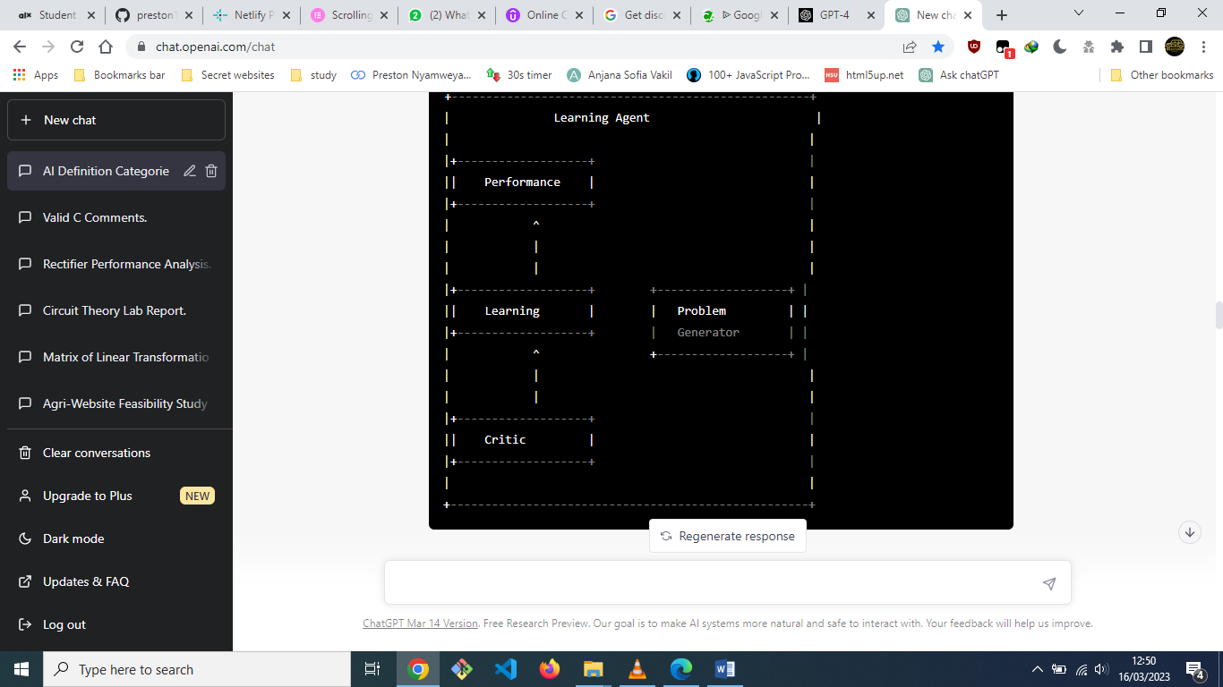

1. Performance: This component is responsible for selecting and executing actions to achieve the agent's goals in its environment.
2. Learning: This component receives feedback from the environment and updates the agent's knowledge to improve its performance. The learning component may use various machine learning algorithms, such as supervised learning, unsupervised learning, or reinforcement learning.
3. Critic: This component evaluates the performance of the learning agent and provides feedback to the learning component on how to improve the agent's behavior.
4. Problem Generator: This component generates new problem instances for the agent to solve, allowing the agent to improve its performance on a wide range of tasks.

Together, these components allow the learning agent to adapt and improve its behavior over time by learning from its experiences in its environment. By iteratively refining its knowledge and adjusting its behavior, the learning agent can become more effective and efficient at achieving its goals.

a problem can be defined by 5 components discuss using example

In artificial intelligence, a problem can be defined by five components, which are:

1. Initial State: This component defines the state of the problem at the start. It specifies the initial conditions that the problem solver has to work with.
2. Actions: This component defines the possible actions that can be taken to transition from one state to another. These actions are usually specified as a set of rules or operators.
3. Transition Model: This component specifies how the actions change the state of the problem. It defines the result of applying an action in a particular state.
4. Goal Test: This component defines the conditions that must be met to solve the problem. It specifies the goal state or states that the problem solver is trying to reach.
5. Path Cost: This component defines the cost associated with each action. The path cost represents the total cost of a sequence of actions that leads from the initial state to the goal state.

Here is an example of how these components can be used to define a problem:

Suppose you are a delivery driver who needs to deliver packages to different locations in a city. Your truck can carry a limited number of packages, and you want to minimize the total distance traveled. You can define the problem as follows:

1. Initial State: The initial state is the location of the delivery driver's truck and the packages to be delivered.
2. Actions: The actions are to load or unload a package at a particular location and to travel to another location.
3. Transition Model: The transition model specifies how the actions change the state of the problem. Loading a package adds it to the truck's load, unloading a package removes it from the truck's load, and traveling to a new location changes the truck's location.
4. Goal Test: The goal test specifies the conditions that must be met to solve the problem. In this case, the goal is to deliver all the packages to their destinations while minimizing the distance traveled.
5. Path Cost: The path cost is the total distance traveled by the delivery driver. The cost of each action is the distance traveled from one location to another.

By defining the problem in this way, it is possible to use search algorithms, such as depth-first search or A* search, to find the optimal solution that minimizes the distance traveled by the delivery driver.

Explain the breadth first search algorithm

Breadth-first search (BFS) is a graph traversal algorithm that explores all the vertices of a graph in breadth-first order, i.e., it visits all the vertices at distance 1 from the starting vertex, then all the vertices at distance 2, and so on, until all vertices have been visited. BFS can be used to find the shortest path between two vertices in an unweighted graph, and it is also used in many AI applications, such as pathfinding, search problems, and optimization problems.

Here is the pseudocode for BFS:

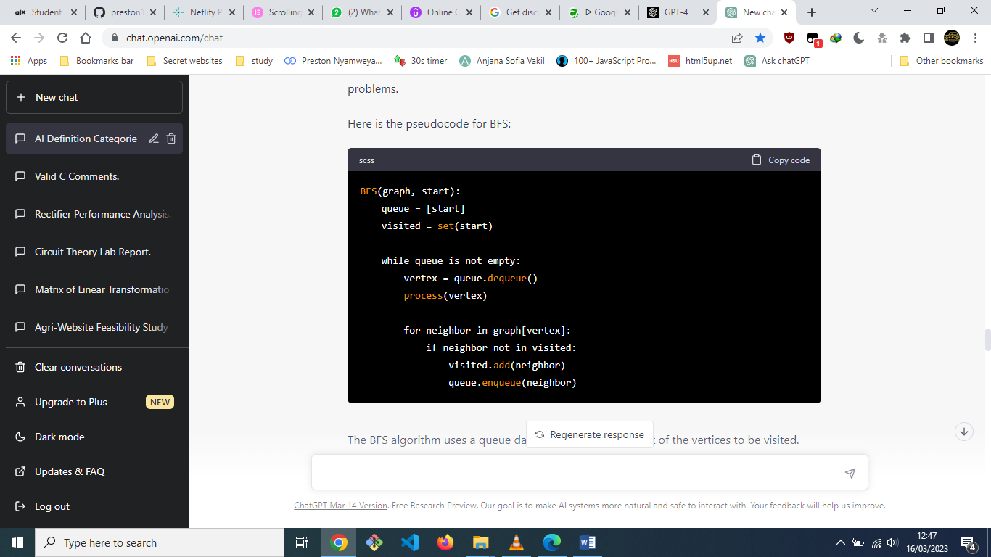

The BFS algorithm uses a queue data structure to keep track of the vertices to be visited. Initially, the starting vertex is added to the queue, and the visited set is initialized with the starting vertex. The algorithm then enters a loop that dequeues a vertex from the queue and processes it. Processing a vertex typically means performing some operation on the vertex, such as printing it or updating its distance from the starting vertex.

The algorithm then explores all the neighbors of the current vertex by iterating over the adjacent vertices in the graph. For each unvisited neighbor, the neighbor is added to the visited set, and its vertex is added to the queue.

The algorithm continues this process until the queue is empty, meaning that all vertices have been visited.

One of the key advantages of BFS is that it guarantees to find the shortest path in an unweighted graph. However, BFS may require a lot of memory if the graph is large, and it can be slow if the graph is dense. Additionally, if the graph contains cycles, BFS may get stuck in an infinite loop.

using a diagram explain how an agent interacts with its environment

Sure, I can explain how an agent interacts with its environment using a diagram.

In artificial intelligence, an agent is a program that perceives its environment through sensors and acts on the environment through actuators. The agent-environment interaction can be represented using a diagram called the agent-environment loop, as shown below:

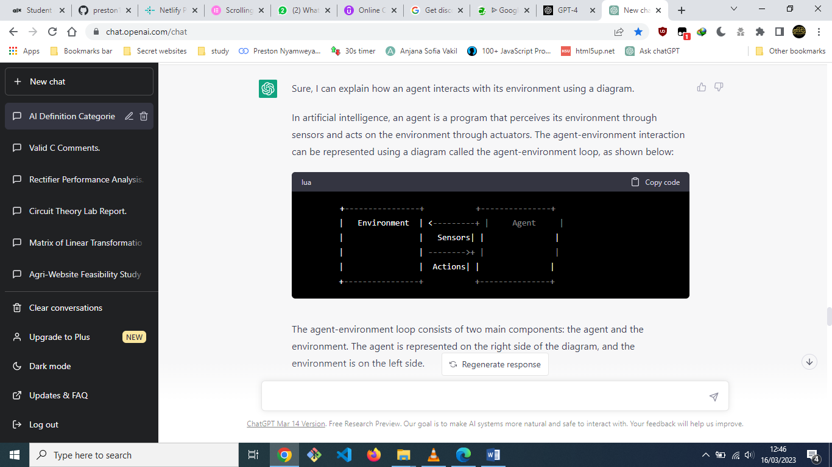

The agent-environment loop consists of two main components: the agent and the environment. The agent is represented on the right side of the diagram, and the environment is on the left side.

The agent perceives its environment through sensors, which can be cameras, microphones, touch sensors, or any other type of sensor that can provide information about the environment. The information perceived by the sensors is represented by the arrow pointing from the environment to the agent.

Based on the information received from the sensors, the agent decides what action to take. The action is represented by the arrow pointing from the agent to the environment. The agent's actions can affect the state of the environment, which can then be perceived by the agent's sensors.

The agent-environment interaction can occur in a continuous or a discrete manner. In a continuous interaction, the agent and the environment interact in real-time, and the agent's actions can affect the environment immediately. In a discrete interaction, the agent and the environment interact in discrete time steps, where the agent's actions only affect the environment at the end of each time step.

Overall, the agent-environment loop diagram illustrates how an agent interacts with its environment by perceiving the environment through sensors and acting on the environment through actuators.

differentiate between a fully observable and partially observable environment

In the context of artificial intelligence, environments can be classified as either fully observable or partially observable, depending on the agent's ability to perceive the environment.

A fully observable environment is one in which the agent has access to the complete and exact state of the environment at all times. In other words, the agent can perceive the environment completely, with no uncertainty or ambiguity. For example, a chess game is a fully observable environment because the state of the game board is fully visible to both players at all times.

On the other hand, a partially observable environment is one in which the agent does not have access to the complete and exact state of the environment. In other words, the agent has incomplete or uncertain information about the environment. For example, driving a car in a foggy weather condition is a partially observable environment because the driver has limited visibility and uncertain information about the road conditions.

In a partially observable environment, the agent needs to make decisions based on its beliefs about the environment, which are updated over time as it receives new information from its sensors. The agent may also need to reason about the possible states of the environment and their probabilities, using techniques such as Bayesian inference or Markov decision processes.

In summary, the key difference between a fully observable and partially observable environment is the amount of information available to the agent about the environment. A fully observable environment provides complete and exact information, while a partially observable environment provides incomplete or uncertain information that the agent must reason about.

using five components that can be used formally to define a problem formulate the vacuum-cleaner problem

The vacuum-cleaner problem can be defined using the following five components:

1. **Initial State**: The initial state of the problem is the location of the vacuum cleaner and the dirty squares in the environment. The vacuum cleaner can be in any of the squares, and some squares may be dirty while others are clean.
2. **Actions**: The actions available to the vacuum cleaner are to move in any of the four directions (up, down, left, right) or to clean the square it is currently on. If the vacuum cleaner moves to a square that is already clean, nothing happens.
3. **Transition Model**: The transition model describes how the state of the environment changes when the vacuum cleaner takes an action. If the vacuum cleaner moves to a new square, the new square becomes the current location of the vacuum cleaner. If the vacuum cleaner cleans a square, the square becomes clean. If the vacuum cleaner moves to a square that is already clean, nothing happens.
4. **Goal Test**: The goal test determines when the problem is solved. In the vacuum-cleaner problem, the goal is to clean all the squares in the environment. The goal test checks whether all the squares are clean and returns true if they are, and false otherwise.
5. **Path Cost**: The path cost is the cost associated with each action. In the vacuum-cleaner problem, the path cost can be defined as one for each movement action and two for each cleaning action.

For example, let's consider an environment with four squares arranged in a square shape. The top-left square is dirty, and the vacuum cleaner is in the bottom-right square. The problem can be formulated as follows:

1. **Initial State**: The initial state of the problem is (2, 2, Dirty), where 2,2 is the location of the vacuum cleaner, and Dirty indicates that the top-left square is dirty.
2. **Actions**: The actions available to the vacuum cleaner are Up, Down, Left, Right, and Clean.
3. **Transition Model**: The transition model can be defined as follows:

* Up: If the vacuum cleaner is not on the top row, it moves one square up. Otherwise, it stays in place.
* Down: If the vacuum cleaner is not on the bottom row, it moves one square down. Otherwise, it stays in place.
* Left: If the vacuum cleaner is not on the leftmost column, it moves one square left. Otherwise, it stays in place.
* Right: If the vacuum cleaner is not on the rightmost column, it moves one square right. Otherwise, it stays in place.
* Clean: If the vacuum cleaner is on a dirty square, the square becomes clean. Otherwise, nothing happens.

1. **Goal Test**: The goal test checks whether all the squares in the environment are clean. In this case, the goal test returns true when the state (2, 2, Clean) is reached.
2. **Path Cost**: The path cost is one for each movement action and two for each cleaning action.

A company is using a simple reflex agent to design a robot. illustrate using a diagram

Here's a diagram illustrating a simple reflex agent for a robot:

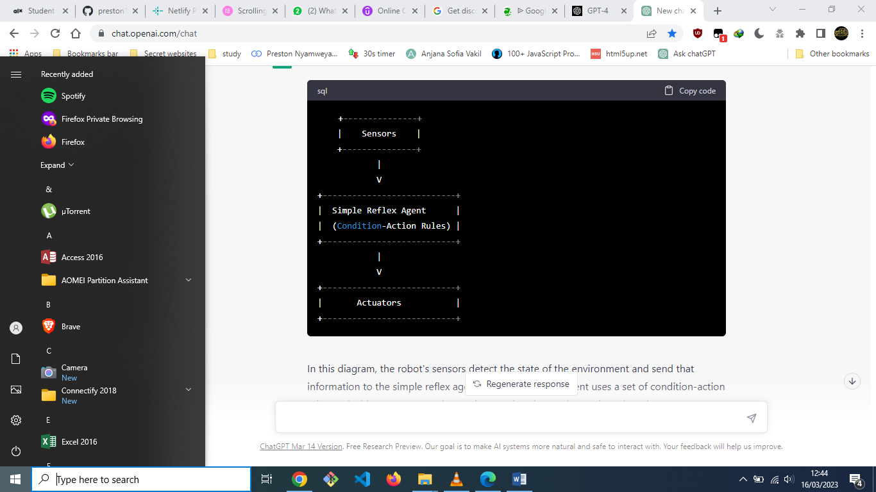

In this diagram, the robot's sensors detect the state of the environment and send that information to the simple reflex agent. The simple reflex agent uses a set of condition-action rules to decide on an appropriate action to take. These rules are based on the current percept and do not take into account any history of previous percepts or actions.

Once the simple reflex agent has selected an action, it sends that information to the robot's actuators, which carry out the action in the environment.

For example, suppose the robot is designed to clean a room. The sensors detect the presence of dirt in the room, and the simple reflex agent uses a condition-action rule to decide to turn on the vacuum cleaner when it detects dirt. The actuators then activate the vacuum cleaner to clean the room.

Note that this type of agent is reactive and does not have the ability to plan or reason about its actions. It simply responds to the current percept and selects an appropriate action based on a set of pre-defined rules.